**Day 7 Live Deployment and Post Launch Services**

**Environment Variables Security and Configuration:**

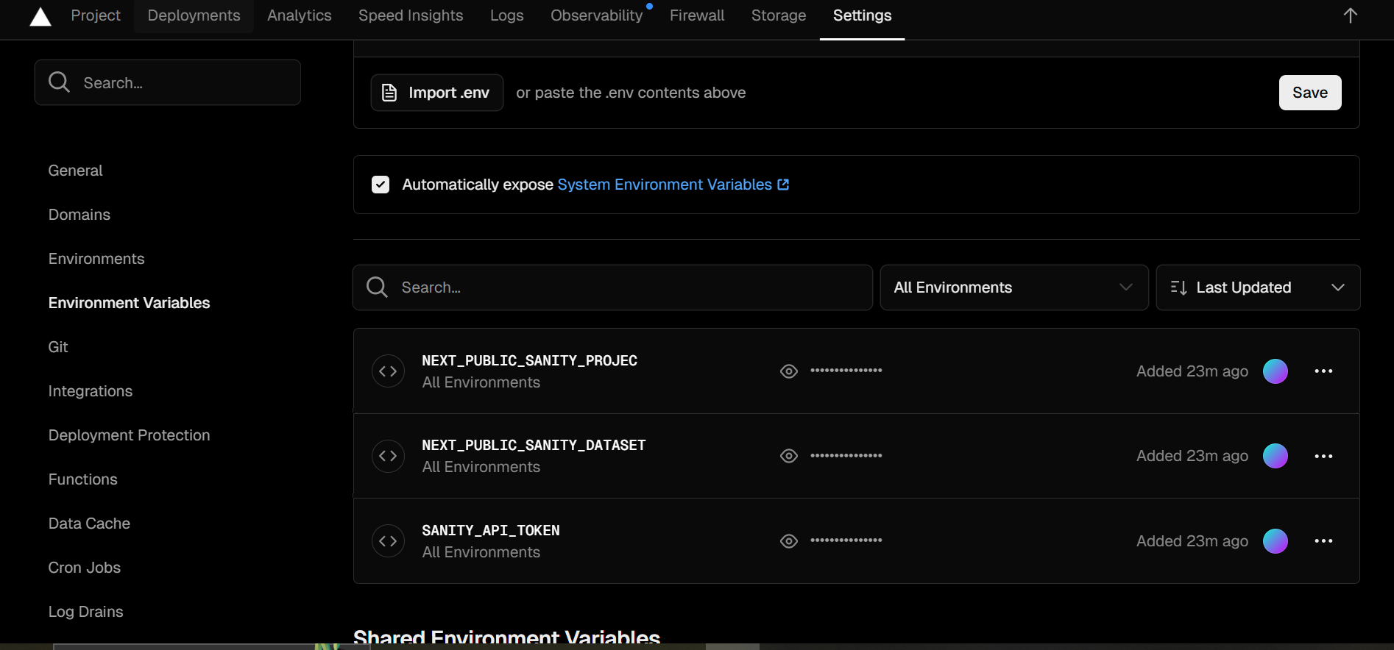

**.SSL And HTTPS Enable:**



**Image Optimization:**

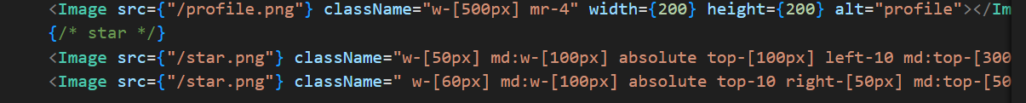

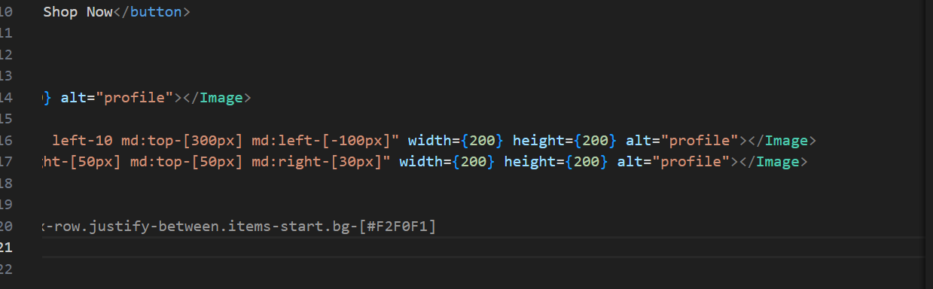

**Alt tag , Src tag , width and height defined in Image tag.**

**Sentry Integration:**

